Drawing and subsequent printing of models and teaching aids

Gymnasium of Dr. Karel Polesného Znojmo, contribution organization
Náměstí Komenského 945/4
Znojmo, 669 75

Contents:
Information about the project 2
Project description 3
What age group is the project intended for? 3
What skills should students master before starting the project? 3
What skills will the students learn as part of the project? 3
Material equipment needed to implement the project 4
Equipment: 4
Financial complexity of the project 4
Mechanical properties of liquids 5
Model 1.: Combined vessels 5
List of parts and materials: 5
Model variation: 6
Complications during creation: 6
Model 2.: Pascal's law 7
Parts and material list: 7
Model variation: 8
Complications during creation: 8
Model 3.: We know hydraulic equipment from practice 9
List of parts and materials: 9
Model variation: 10
Mailer construction: 10
Aids for other subjects 12
Model 4.: Whistle for physical education 12
Parts and material list: 13
Model variation: 13
Complications during creation: 13
Model 5.: Christmas cutter 14
Parts and material list: 14
Model variation: 14
Complications during creation: 14
Model 6.: Cartography of the Czech Republic 15
Parts and material list: 15
Model variation: 15
Complications during creation: 15
Model variations:

Complications during creation: 16

Project information

Project description

The project is focused on drawing and 3D printing of teaching aids. In the first part of the project, we will draw and print tools for understanding Pascal's law. The second part of the project will deal with a model of a real device, where we will use Pascal's law in a hydraulic device.

What age group is the project intended for?

The project is created for the seventh year of elementary school. The tools are used directly in physics classes when teaching Pascal's law.

What skills should students master before starting the project?

Basics of 3D modeling and 3D printing.

What skills will the students learn as part of the project?

Creation of technical drawing, planning, prototyping
3D modeling in CAD software
Knowledge of real and model functioning of hydraulic devices

Material equipment needed to implement the project

Device:

- 3D Printer
- Colored filaments for better orientation in parts
- Instant glue gel (melt gun)
- Other parts are specified for each model

Financial complexity of the project

The total costs of the project are in crowns. A few meters of filament is used and other costs are negligible. With proper use and handling, the usability and lifespan of the aids is unlimited. The individual list of materials and components will always be listed under a specific model.

Mechanical properties of liquids
Before we get down to the actual creation of tools, we will first focus on repeating the basic mechanical properties that we already know from the physics lessons of the previous year.
- Almost incompressible
- It easily changes shape according to the container in which it is located
- Fluidity
- The liquid level always stabilizes in a horizontal position

Model 1.: Combined vessels

With this simple model, we will verify the mechanical properties of liquids. We find that liquids are really liquid, they change their shape easily, they are not compressible and their level always stabilizes in a horizontal position. In addition, we will add another knowledge about the behavior of liquids in connected vessels.

List of parts and materials::

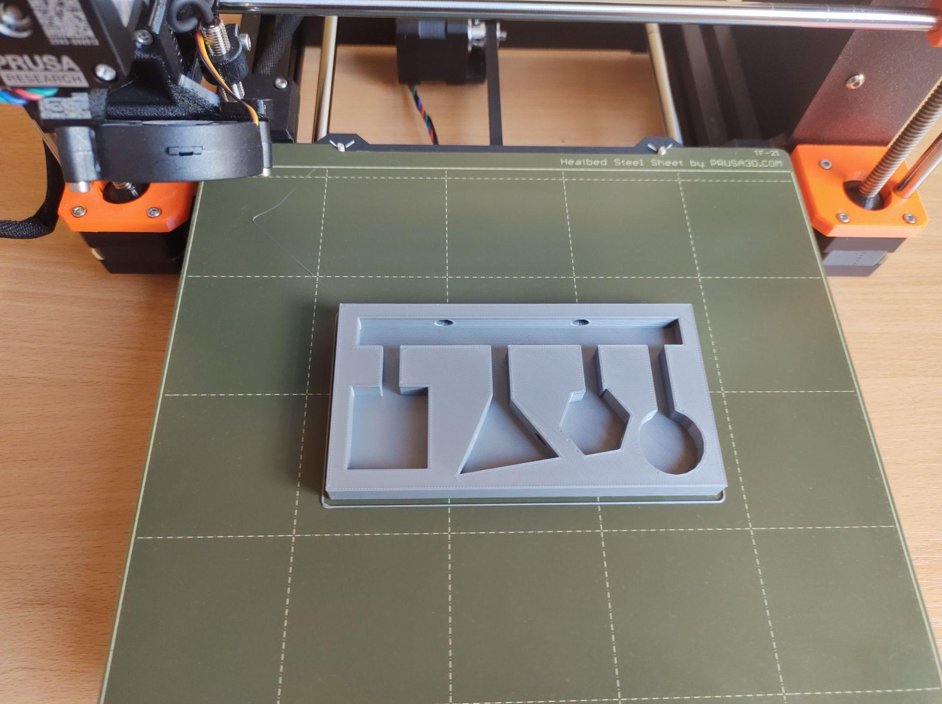
- List of parts and materials:
- Filament for 3D printer
- Plexiglas
- Silicone
- Gel glue
- Liquid

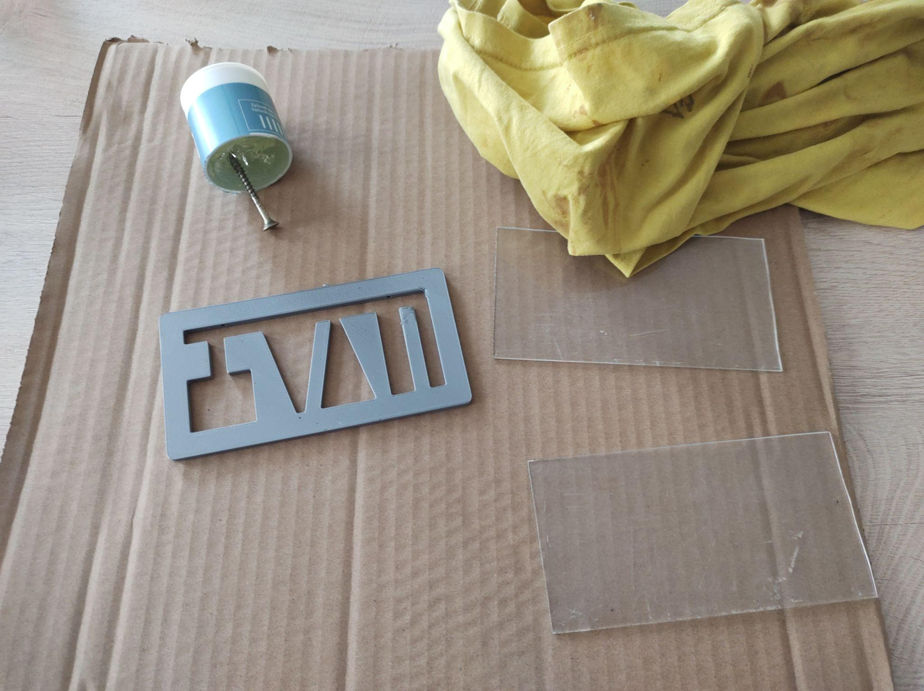
Model variations:

Each student modeled their own design of connected containers. Some made both sides transparent, so they had more work with gluing and cutting plexiglass, but the resulting model is more attractive for use in school as aids

Complications during creation:

The first predicament arose when drawing. Some students did not understand that we needed to make two holes in the model. One filling hole and the other hole through which the forced air would leave the model.
The second problem occurred during cutting and gluing, as our school is not equipped with workshops. We had to buy not only plexiglass, but also knives, washers and glue. We then created everything in a classic classroom, where the furniture was damaged

Model 2.: Pascal's law

If an external pressure force acts on a liquid in a closed container, then the pressure at every point in the liquid will increase by the same amount. This is how Pascal's law sounds, which inspired us to create the next model. Pascal's law is mainly used in practice with hydraulic devices, which is why we made a small hydraulic device.
At first glance, the model looks simple, but it must first be drawn, with an accuracy of tenths of a millimeter, so that the o-rings fit exactly on the piston and at the same time perfectly seal our little mailer. We printed two models, each in a different size. Subsequently, we connected them with a tube, and thus obtained a model of Pascal's law.

List of parts and materials:
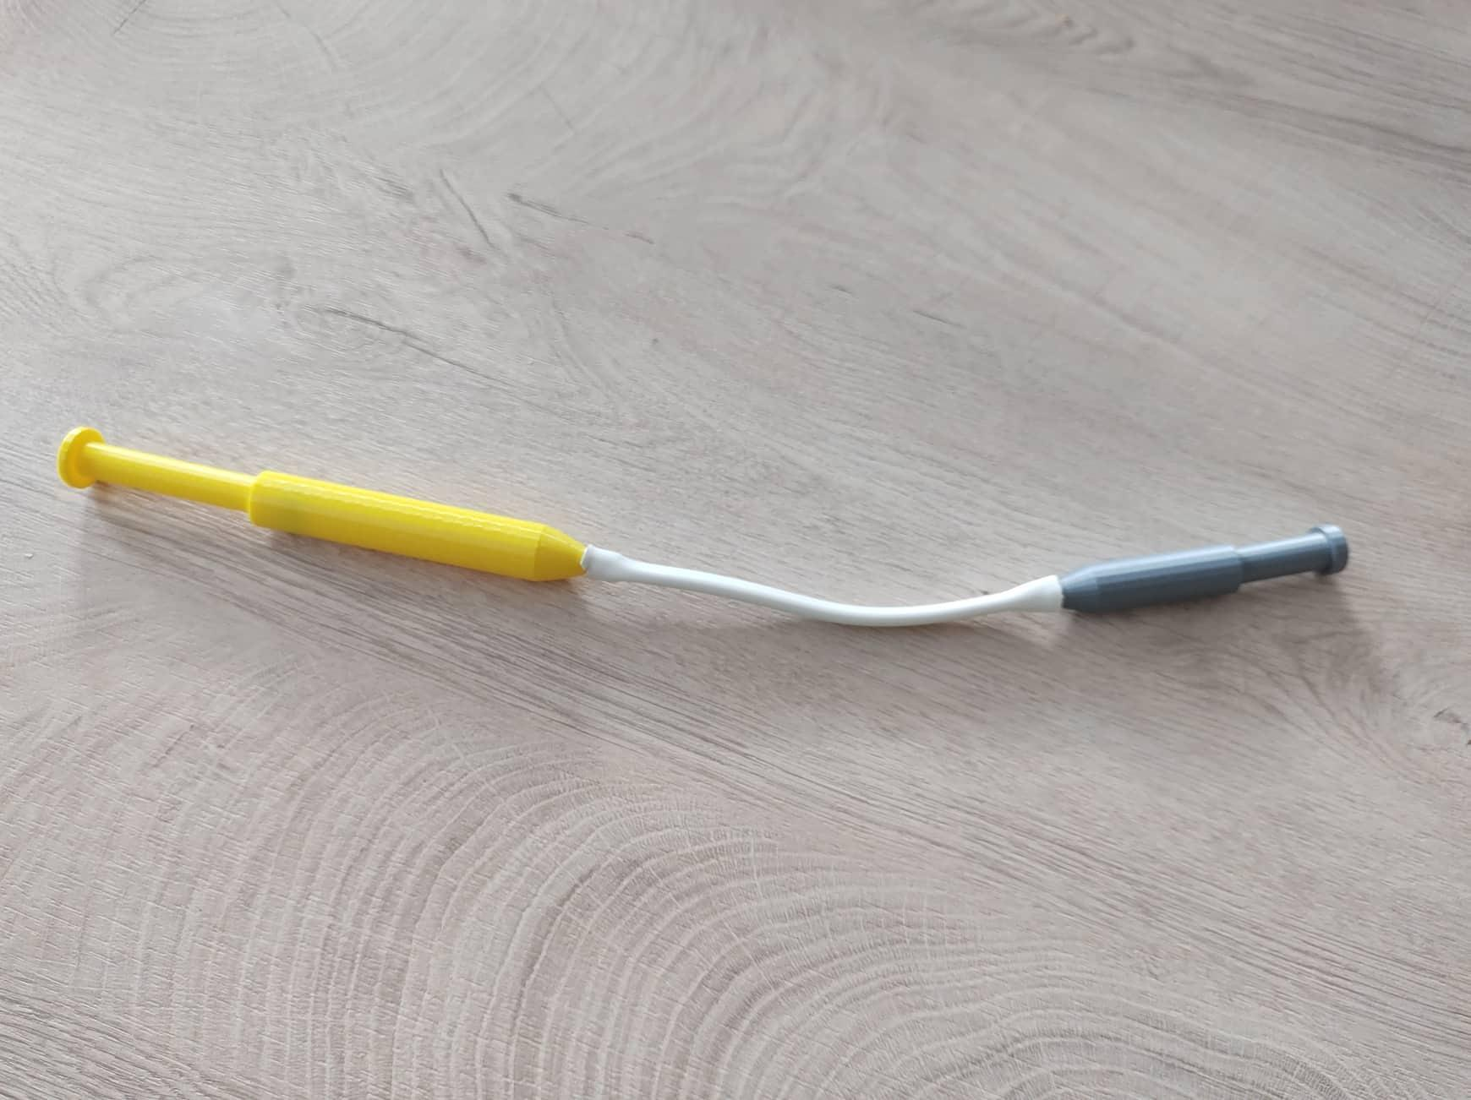
- Filament for 3D printer
- O-rings of various diameters
- Millimeter caliper
- Liquid

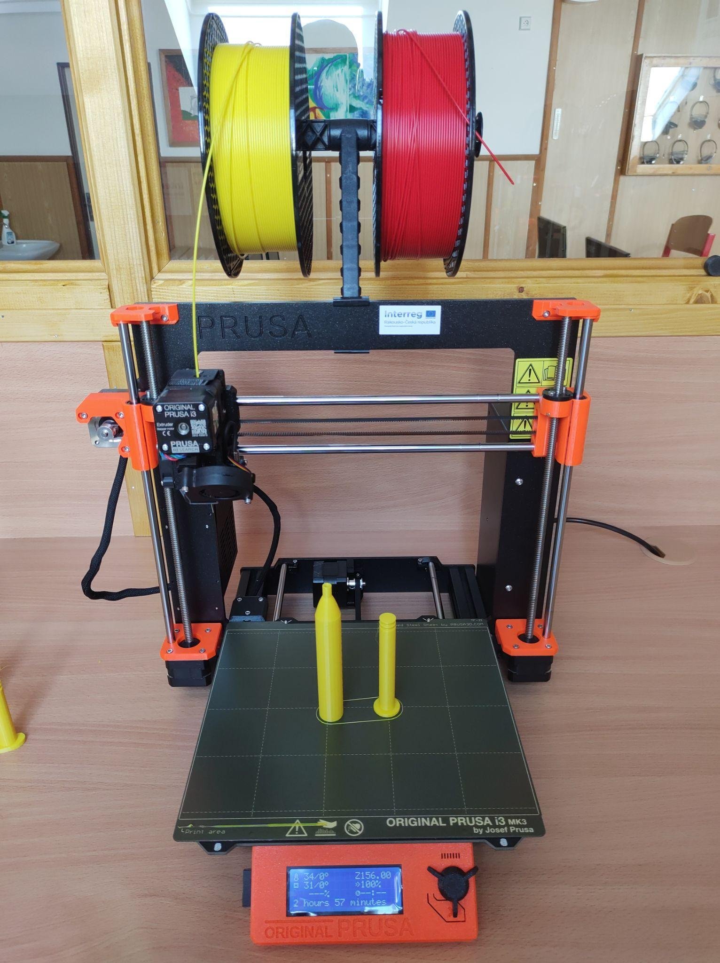

Model variation:

On this model, it is important to seal the exact gap between the piston and the body of the product, so we used round shapes with o-rings on them. But the students soon realized that the shape of the product can be arbitrary, they just have to keep the inner round opening. Really strange creations were created, but in most cases functional.

Complications during creation::

The only complication was that pupils in the 7th year of primary school cannot measure with a millimeter caliper. In the first lesson, I had to prepare the gauges and measuring samples, and the students carefully measured, wrote down and checked the samples.

Model 3.: We know hydraulic equipment from practice

The previous examples serve as teaching aids for physics classes. But they are still only models on which it is not entirely clear where the given physical phenomenon is used in practice. That's why we wanted to create a model that everyone knows, but doesn't realize that they use, for example, hydraulics, which is discussed in physics in the seventh grade.
I chose a forklift, everyone has already seen it and can imagine how important it is in everyday life. We found the cart model on Thingiverse and then redesigned it to our own image.

List of parts and materials:

- Filament for 3D printer
- Syringe (or previous model)
- A tube
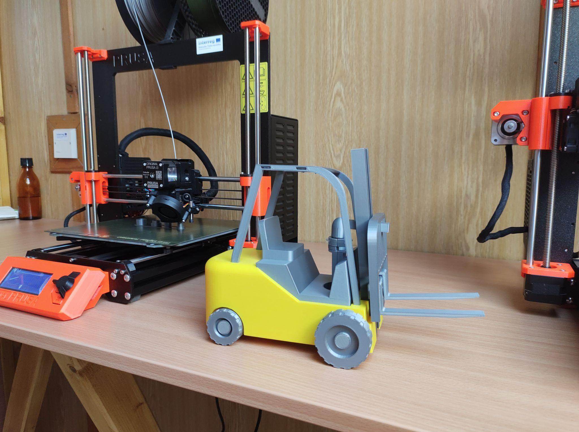
- Liquid

Model variations:

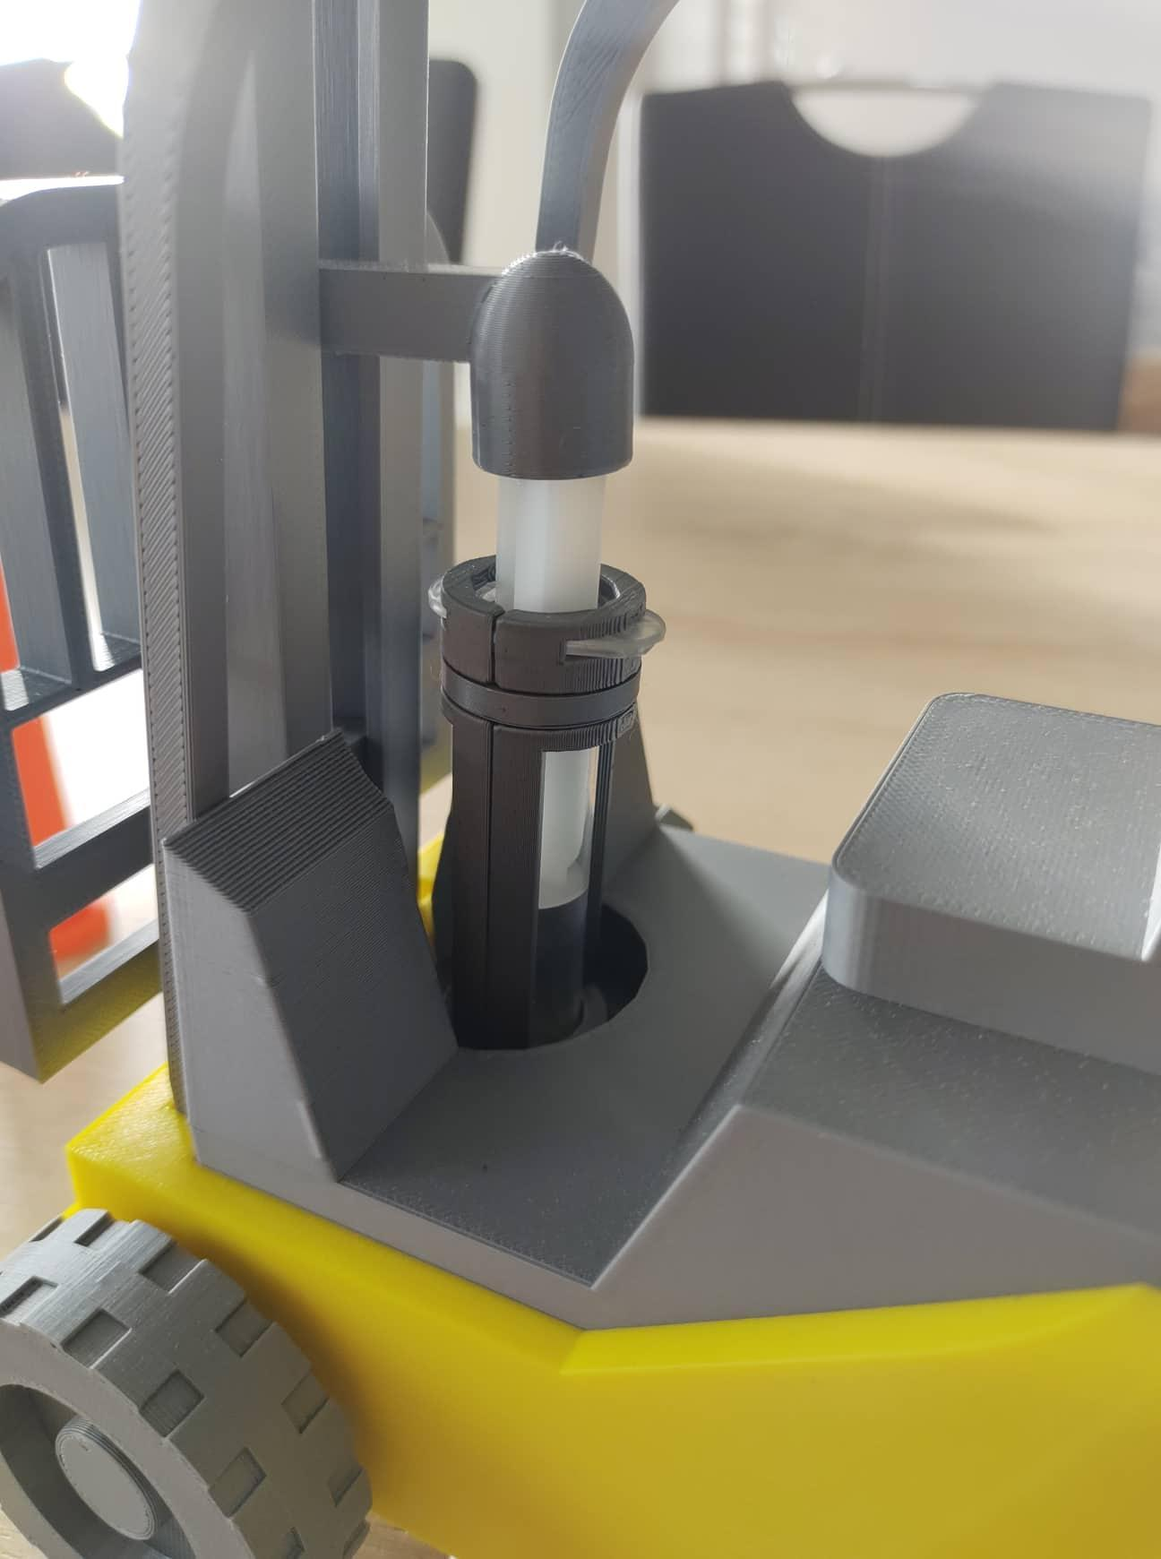
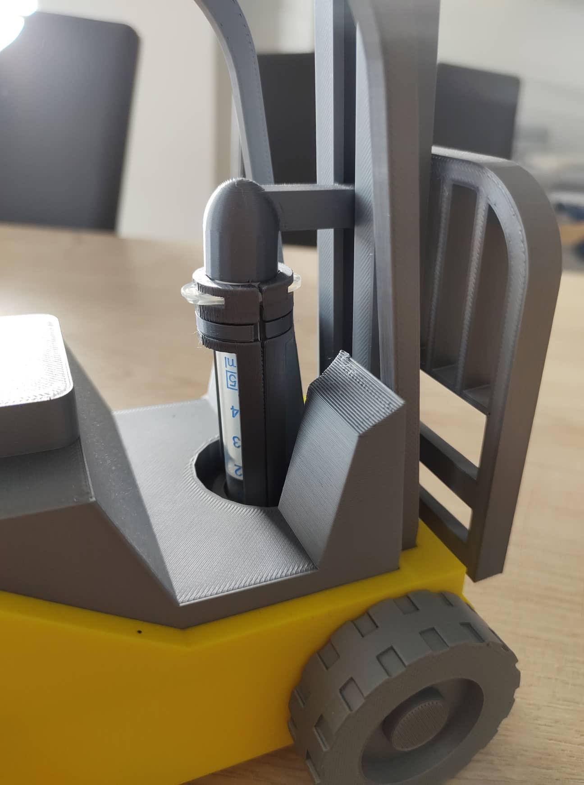
The lifting device, as we designed it, drew it and printed it, can be used on several models. As already mentioned, we processed the forklift. However, the mailer model itself can be used in most lifting machines, whether they are excavators, tractors, hoists, car lifts, etc.

Mailer construction:
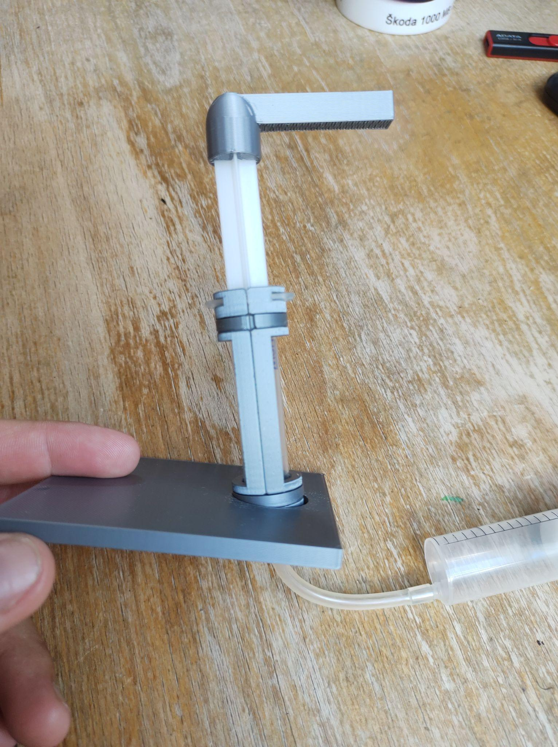
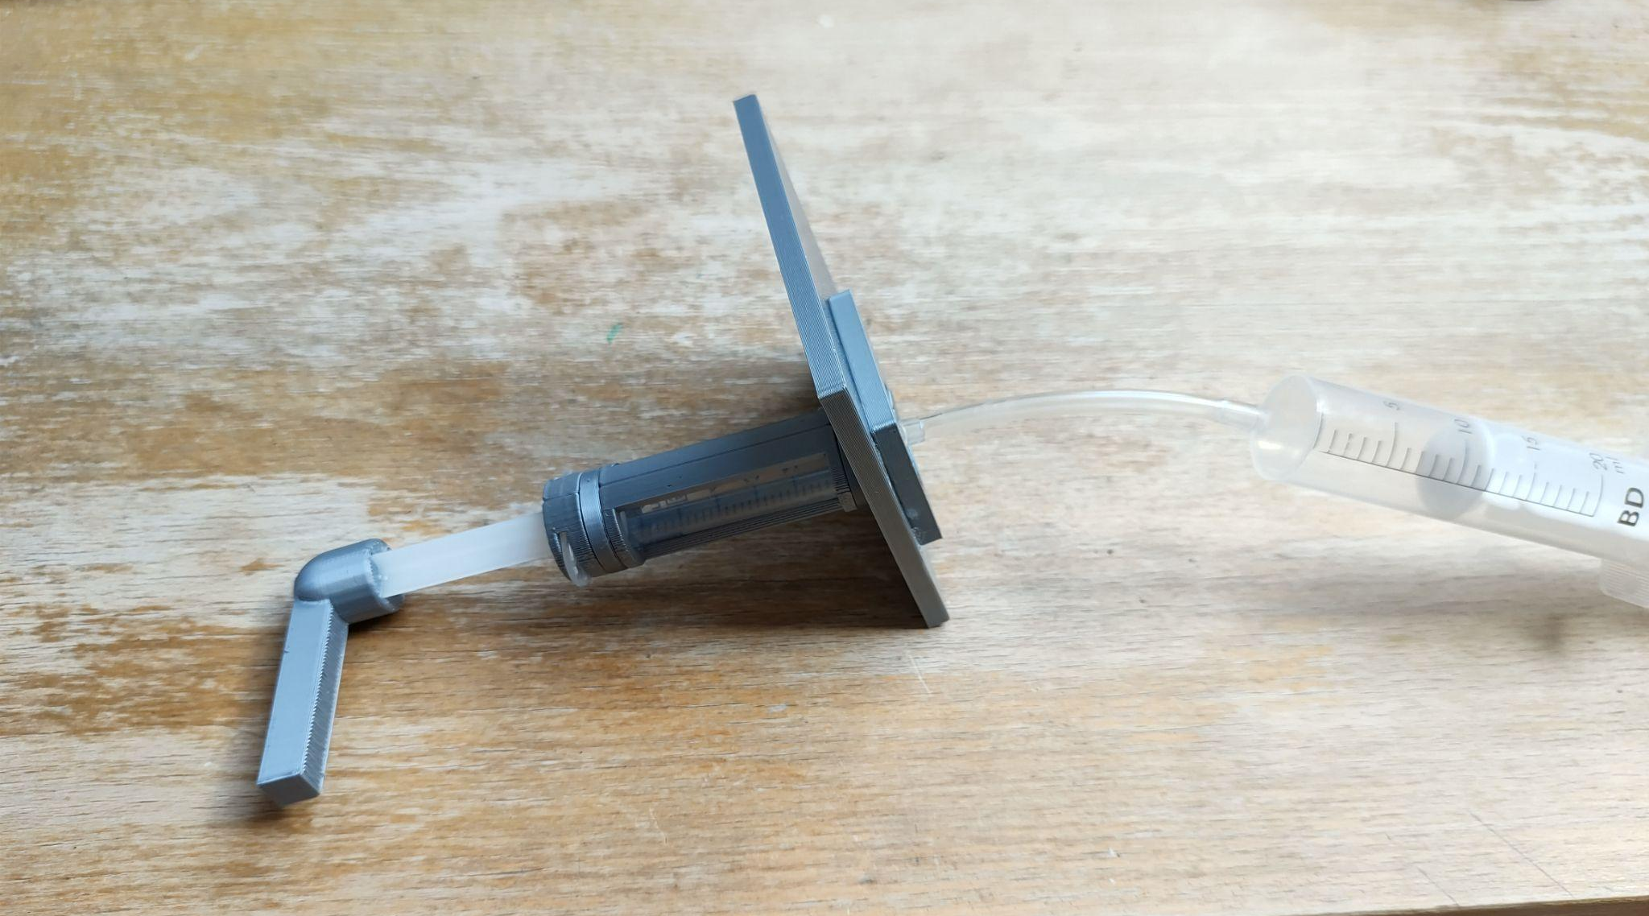
The lifting device itself is created from a syringe around which we created a wrapper. This wrap wraps around the syringe and holds it upright. Since the lifting device does not run perpendicular to the syringe, we had to solve the movement of the entire piston not only up and down, but also forward and backwards. We solved this by placing the piston on the pin in the lower part. After connecting the tubing and the second syringe, the pistons can be moved up and down, which raises the forks of the forklift for us.

Aids for other subjects

For a long time we have devoted ourselves to tools that are applicable in physics. But we all know that we have other subjects at school. In this part of the work, we will look at the aids that we created for other subjects.
3D printing can really be used in all subjects, but unfortunately the school year is too short to cover all subjects, so we will only show a few models here.

Model 4.: Whistle for physical education

The whistle is one of our first models that the students created themselves. Since vector graphics are taught at our school, the students first created the whistle in 2D in the InkScape program. The next step was to export to .svg format. This format will already open the TinkerCad online program, in which we converted the model to 3D.

List of parts and materials:
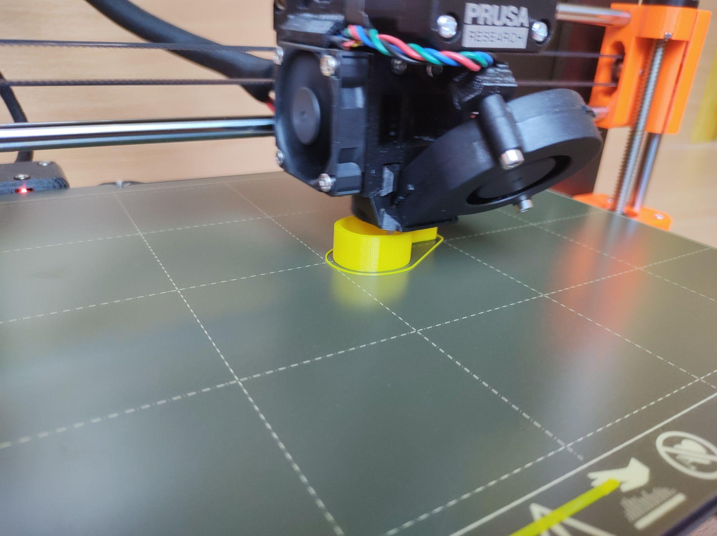
- Filament for 3D printer
- Neck lace

Model variations:

The only variations we could think of for such a simple model were the shapes. Pupils created really interesting and futuristic shapes of whistles. Of course, some worked well, others not so much.
Another idea was to put a ball inside. With this activity, the students learned to pause the print in progress, insert a ball and start the print again.

Complications during creation:
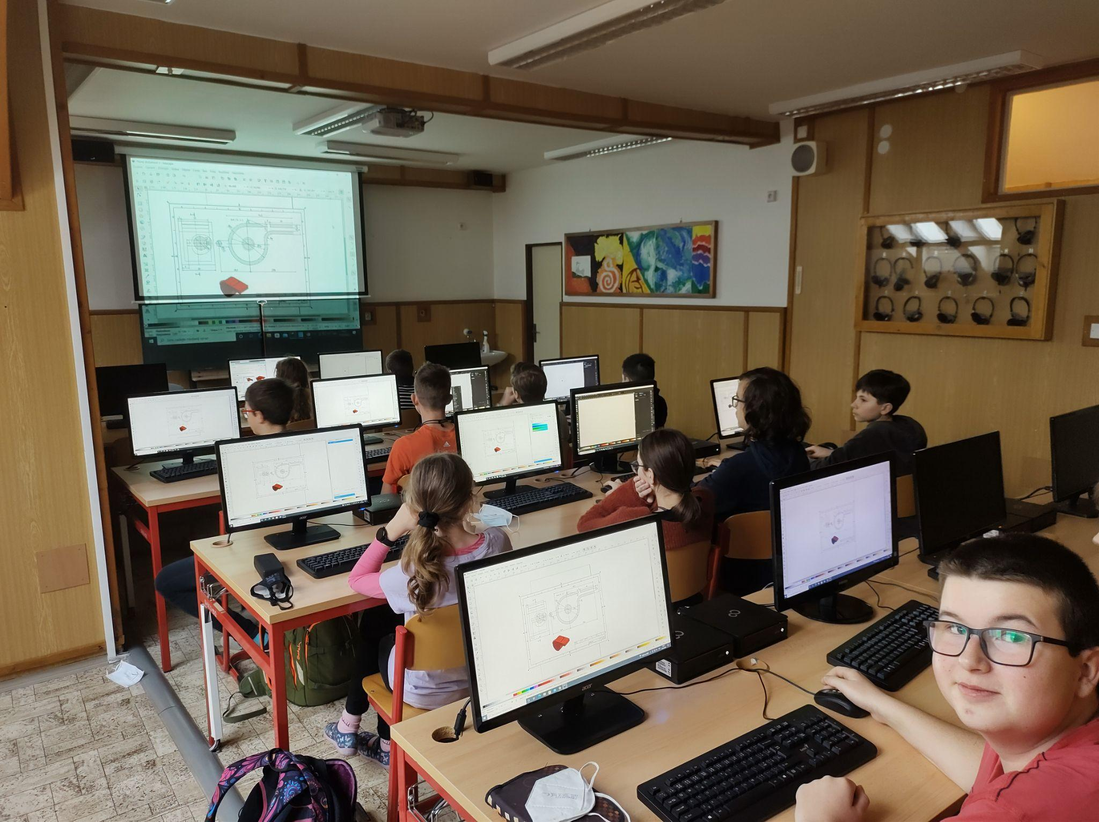
As I already mentioned, the complications consisted in too much creativity in the appearance of the whistle, which led to the non-functionality of some whistles.
Also pupils carelessly put the individual parts of the whistles on top of each other, and thus there were inaccuracies during printing.

Model 5.: Christmas cookie cutter

Around the Christmas holidays, the school always opens a Christmas cafe. In addition to coffee, the cafe also sells sweet pastries, which are always baked by the students themselves. That's why we decided to make Christmas cookie cutters.

List of parts and materials:
- Filament for 3D printer

Model variations:

Every student can come up with any shape they can think of, so in the Christmas cafe we had sweets in the shape of stars, tractors or well-known cartoon characters.

Complications during creation:

The student must realize that the entire mold cannot be of one width. Another complication was with the larger molds, when they started to twist and we had to create fillings.

Model 6.: Cartography of the Czech Republic

Together with the pupils, we came up with the creation of a 3D puzzle of the Czech Republic. After that, we got down to the actual implementation, which resulted in a great geography aid that will practice the regions of the Czech Republic.

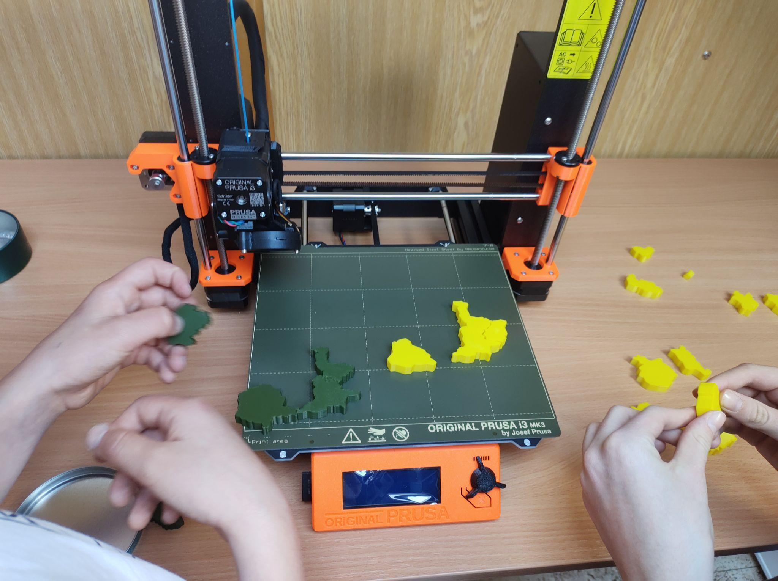
List of parts and materials:

- Filament for 3D printer

Model variations:

We created a 3D map of the Czech Republic, but the concept itself can be used for any map or logo of a company, school, etc.

Complications during creation:

This model really took us a lot of time, because the students had to model every curve and every arc of the borders of the individual regions.
The hitch occurred when we were supposed to insert Prague into the Central Bohemian Region, so we had to reduce Prague by a certain percentage.

Model 7.: Cell
The last model we created was a plant or animal cell. The models really worked out and the biology teachers accepted our models with enthusiasm.

List of parts and materials:
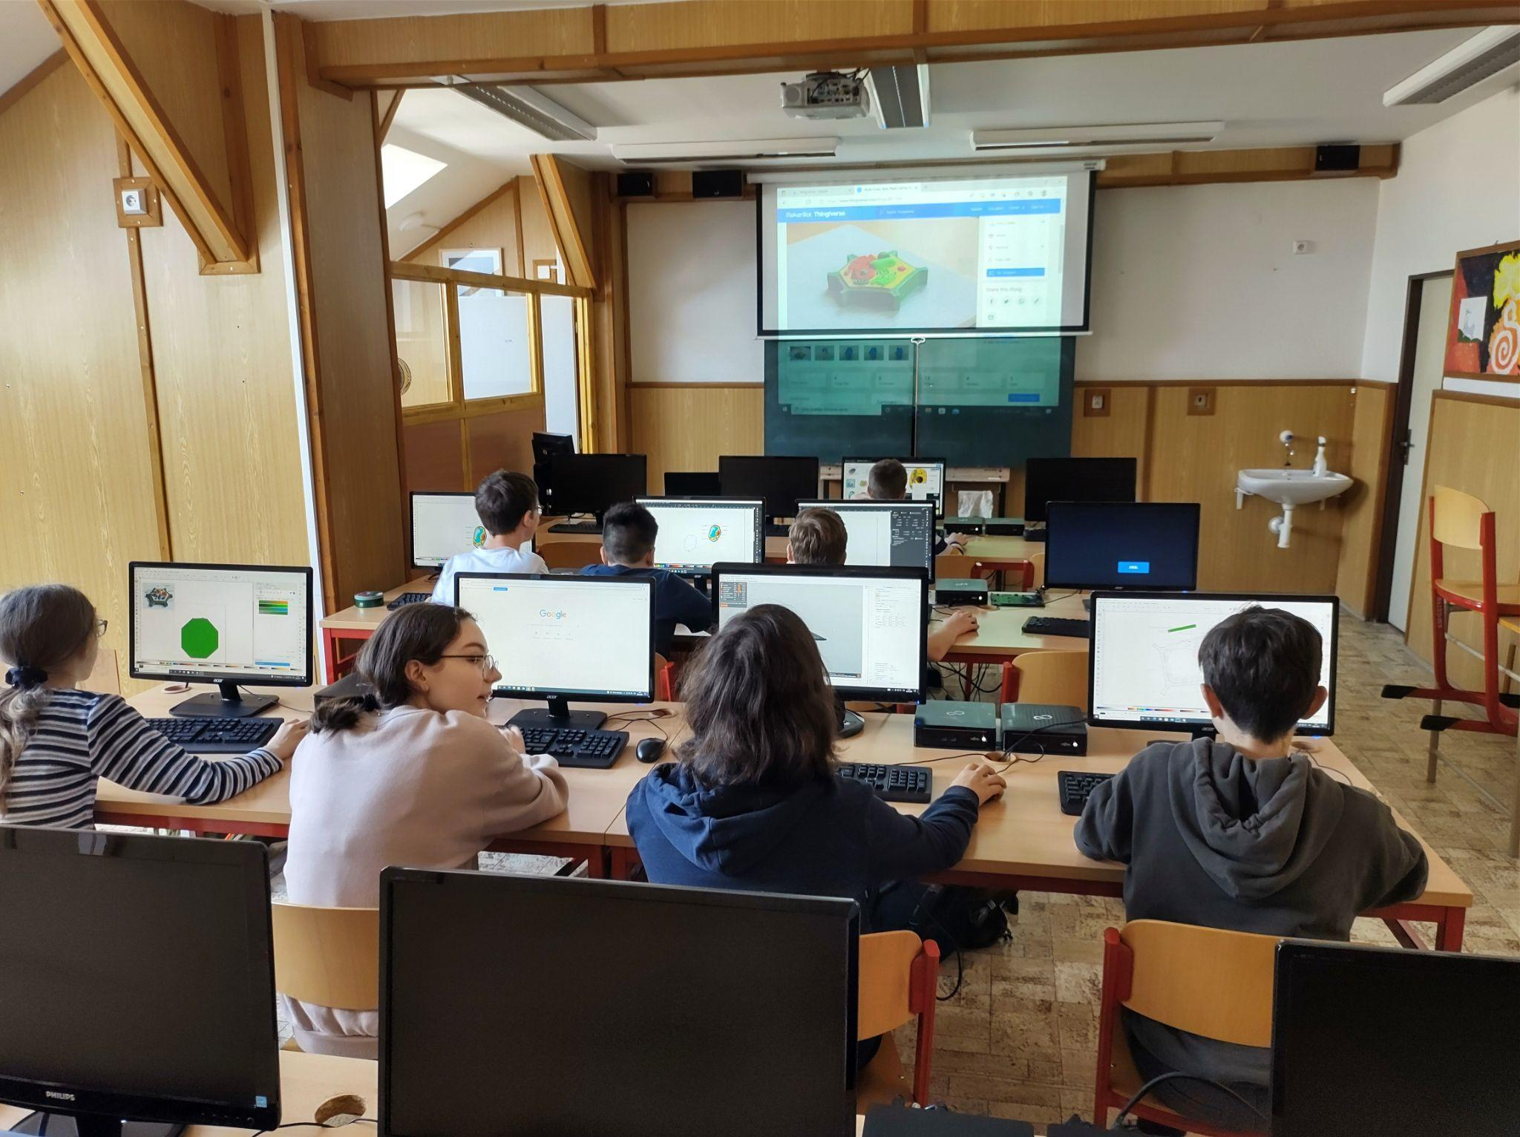
- Filament for 3D printer
- Colors

Model variations:

Any part of the human or non-human body can be modeled using 3D printing, thus providing usable models for teaching.

Complications during creation:

We decided to separate the individual cells by color for better readability, so we had to color them at the end, or use colored filaments.

